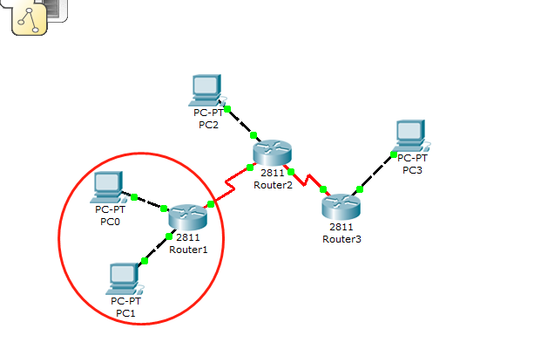

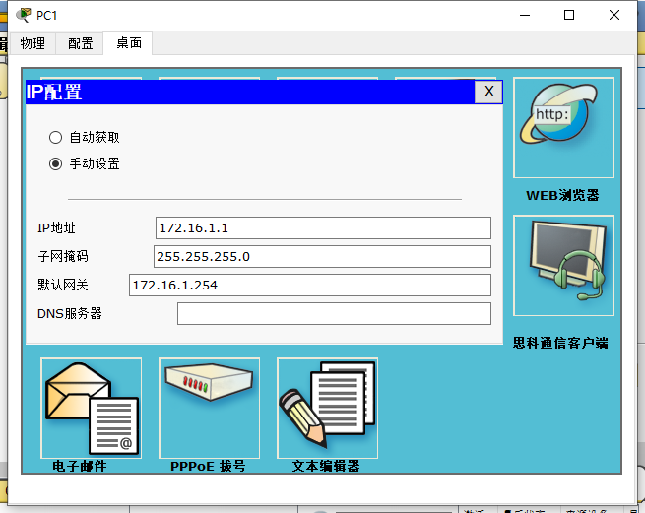

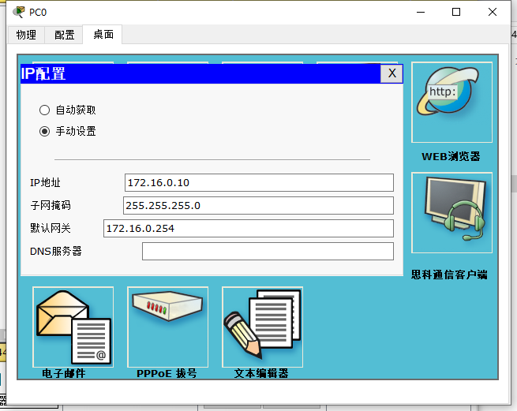

Router1配置信息

Router1>enable

Router1#show running-config

!

hostname Router1

interface Loopback 0

ip address 1.1.1.1 255.255.255.252

!

interface FastEthernet0/0

ip address 172.16.0.254 255.255.255.0

duplex auto

speed auto

!

interface FastEthernet0/1

ip address 172.16.1.254 255.255.255.0

duplex auto

speed auto

!

interface Serial0/3/0

ip address 10.1.1.1 255.255.255.252

clock rate 125000

!

router ospf 1

router-id 1.1.1.1

log-adjacency-changes

network 1.1.1.0 0.0.0.3 area 0

network 172.16.0.0 0.0.0.255 area 0

network 172.16.1.0 0.0.0.255 area 0

network 10.1.1.0 0.0.0.3 area 0

!

end

Router1-接口-配置信息

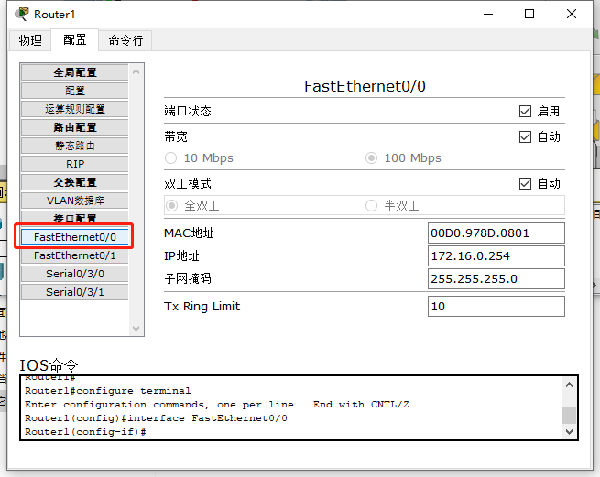

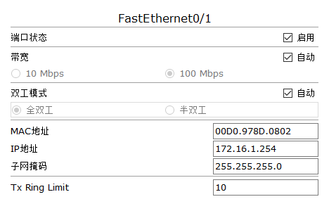

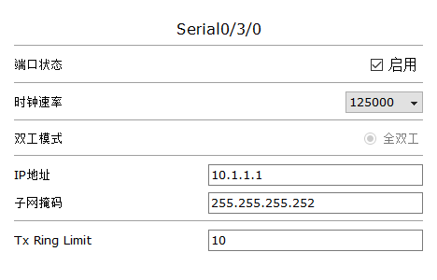

Router1本地回环接口配置过程：

Router1#configure terminal

Router1(config)#interface Loopback0

Router1(config-if)ip address 1.1.1.1 255.255.255.252

Router1-OSPF路由配置过程：

Router1#configure terminal

Router1(config)#router ospf 1

Router1(config-router)#router-id 1.1.1.1

Router1(config-router)#network 1.1.1.0 0.0.0.3 area 0

Router1(config-router)#network 172.16.0.0 0.0.0.255 area 0

Router1(config-router)#network 172.16.1.0 0.0.0.255 area 0

Router1(config-router)#network 10.1.1.0 0.0.0.3 area 0

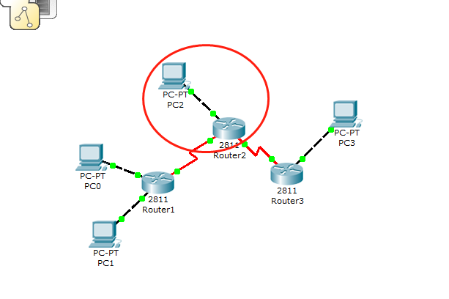

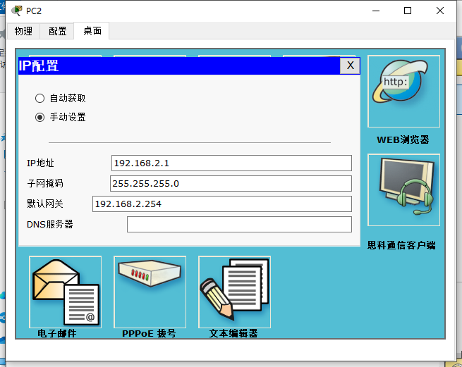

Router2配置信息

Router2>enable

Router2#configure terminal

Router2#do show running

!

hostname Router2

interface Loopback0

ip address 1.1.1.2 255.255.255.252

!

interface FastEthernet0/0

ip address 192.168.2.254 255.255.255.0

duplex auto

speed auto

!

interface Serial0/3/0

ip address 10.1.1.2 255.255.255.252

clock rate 125000

!

interface Serial0/3/1

ip address 11.1.1.2 255.255.255.252

clock rate 125000

!

router ospf 1

router-id 1.1.1.2

log-adjacency-changes

redistribute static subnets

network 1.1.1.0 0.0.0.3 area 0

network 192.168.2.0 0.0.0.255 area 0

network 10.1.1.0 0.0.0.3 area 0

!

ip classless

ip route 222.1.3.0 255.255.255.0 11.1.1.1

End

Router2-接口-配置信息

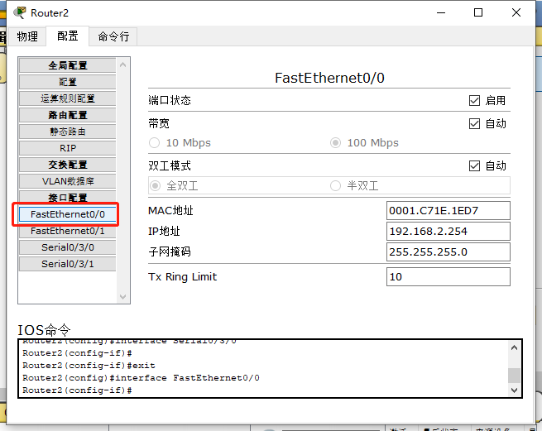

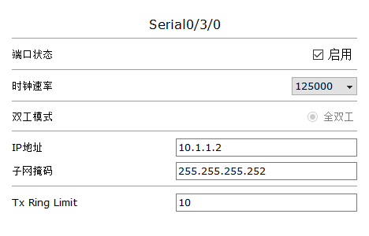

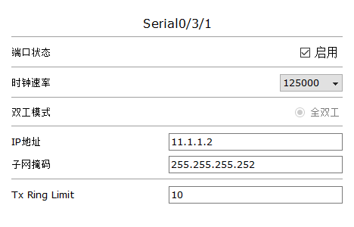

Router2-本地回环接口-配置过程

Router2>enable

Router2#configure terminal

Router2(config)# interface Loopback0

Router2(config-if)# ip address 1.1.1.2 255.255.255.252

Router2-OSPF路由-配置过程

Router2#configure terminal

Router2(config)#router ospf 1

Router2(config-router)#router-id 1.1.1.2

Router2(config-router)#redistribute static subnets

Router2(config-router)#network 1.1.1.0 0.0.0.3 area 0

Router2(config-router)#network 192.168.2.0 0.0.0.255 area 0

Router2(config-router)#network 10.1.1.0 0.0.0.3 area 0

Router2-静态路由-配置过程

Router2(config)#ip route 222.1.3.0 255.255.255.0 11.1.1.1

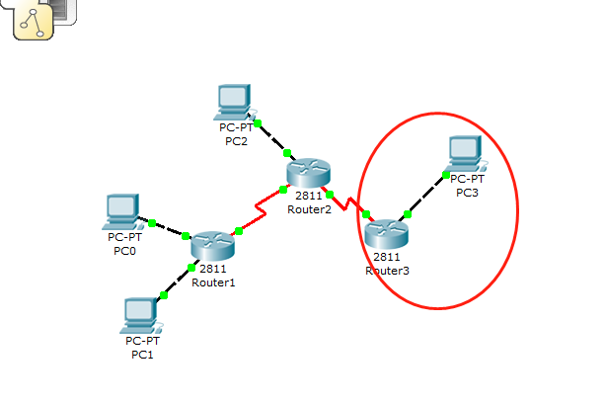

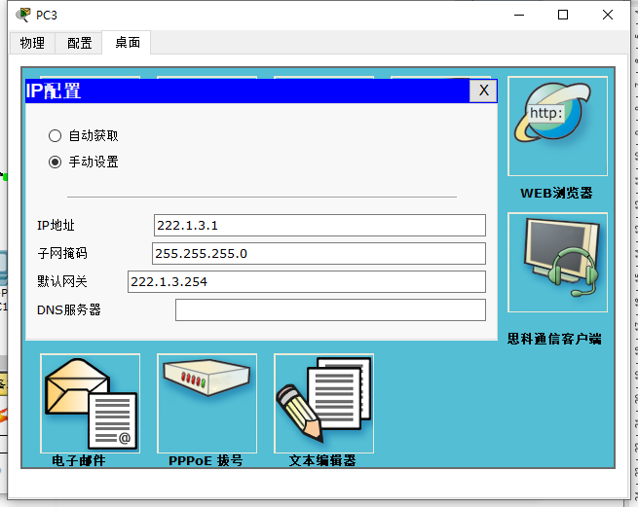

Router3配置信息

Router3>enable

Router3#show running-config

!

hostname Router3

!

interface FastEthernet0/0

ip address 222.1.3.254 255.255.255.0

duplex auto

speed auto

!

interface Serial0/3/0

ip address 11.1.1.1 255.255.255.252

clock rate 125000

!

ip classless

ip route 192.168.2.0 255.255.255.0 11.1.1.2

ip route 172.16.0.0 255.255.255.0 11.1.1.2

!

End

Router3接口配置信息

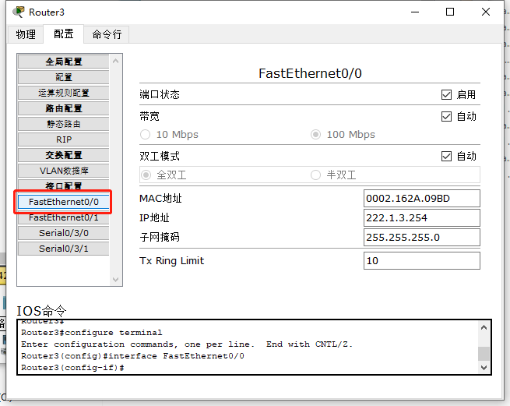

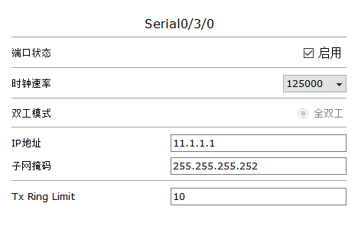

Router3-静态路由-配置信息

Router3>enable

Router3#configure terminal

Router3(config)#ip route 192.168.2.0 255.255.255.0 11.1.1.2

Router3(config)#ip route 172.16.0.0 255.255.255.0 11.1.1.2